Amazon Sales Performance Analysis
Excel | PostgreSQL | Power BI
1.Project Overview
End-to-end analysis of 128K+ Amazon India order records (Mar-Jun 2022) using Excel, PostgreSQL and Power BI to measure sales performance, product and regional drivers, fulfilment and cancellations.
2. Business Problem
The project aimed to analyse sales performance, identify the products and regions driving revenue, evaluate order and fulfilment performance, and identify cancellation patterns and customer segment differences.
3. Dataset
Source: Kaggle – Amazon Sale Report
Records: 128K+ after data cleaning
Period: March–June 2022
Key fields: Orders, sales amount, product category, state, fulfilment, order status and B2B/B2C segment.
4. Data cleaning & preparation
- Removed duplicate records, reducing the dataset from 128,976 to 128,808 rows.
- Extracted Year and Month from the date field using YEAR() and MONTH().
- Converted the Amount column from text to numeric format in PostgreSQL.
- Standardised city and state text casing for data consistency.
5. Analytical Questions
- What is the overall sales performance and average order value?
- How do sales vary across months, product categories and states?
- Which fulfilment method handles the highest number of orders?
- What is the order cancellation rate, and where are cancellations concentrated?
- How do B2B and B2C sales compare?
6. Analysis Performed
- Excel: Created PivotTables to analyse monthly sales, category performance, state-wise sales and order-status distribution.
- PostgreSQL: Queried sales, unique orders, AOV, monthly trends, category/state performance, fulfilment, cancellations and B2B/B2C sales.
- Power BI: Built an interactive two-page dashboard covering KPIs, sales trends, category and state performance, fulfilment, cancellations, order status and customer segments.

7.Visuals
Excel | PivotTable Analysis
Monthly Sales • Category Performance • State Sales • Order Status
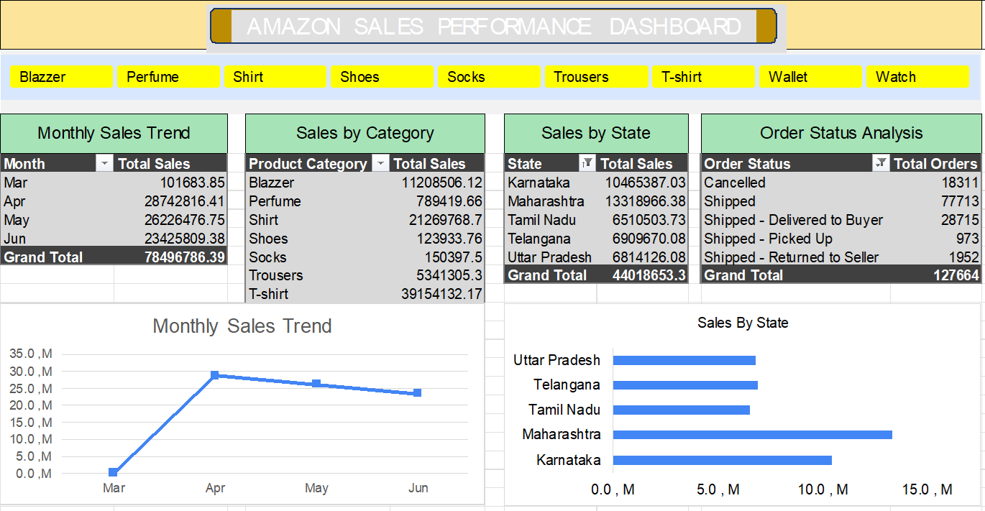

PostgreSQL | SQL Analysis
Sales • Orders • AOV • Monthly Trends • Categories • States • Cancellations
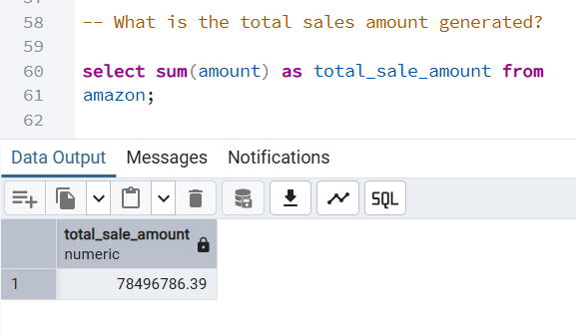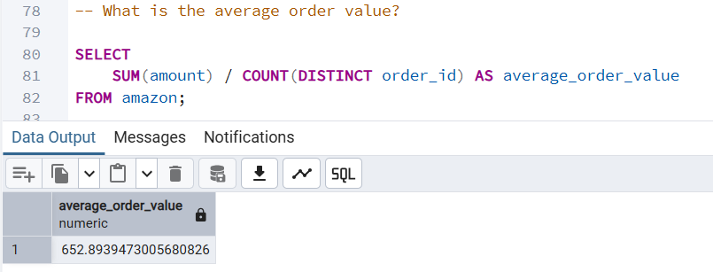
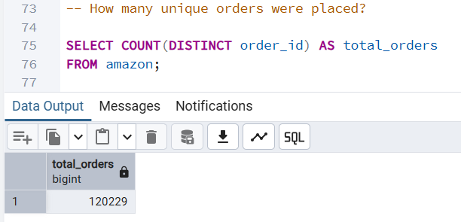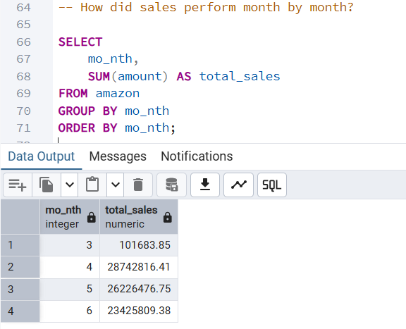

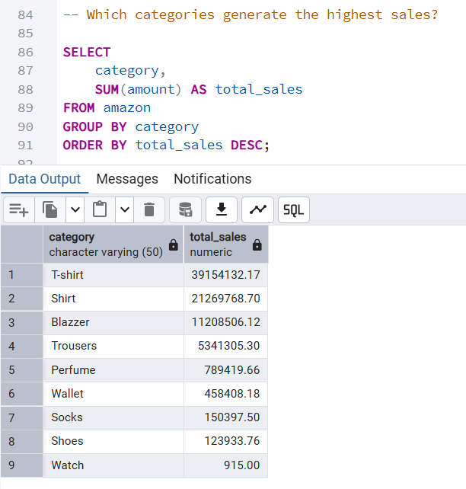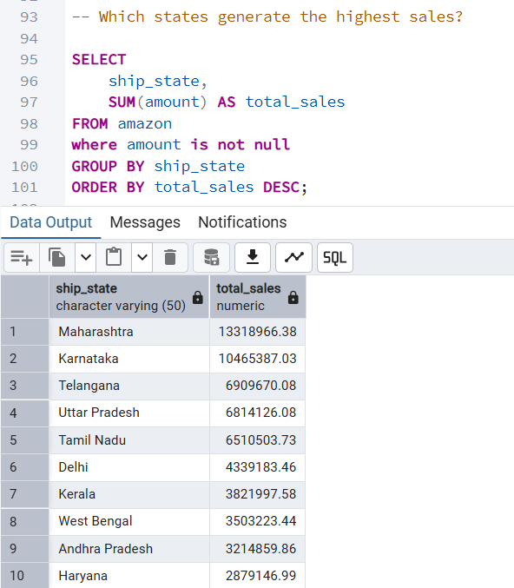

Power BI | Interactive Dashboard
Executive Overview • Geographic & Order Analysis
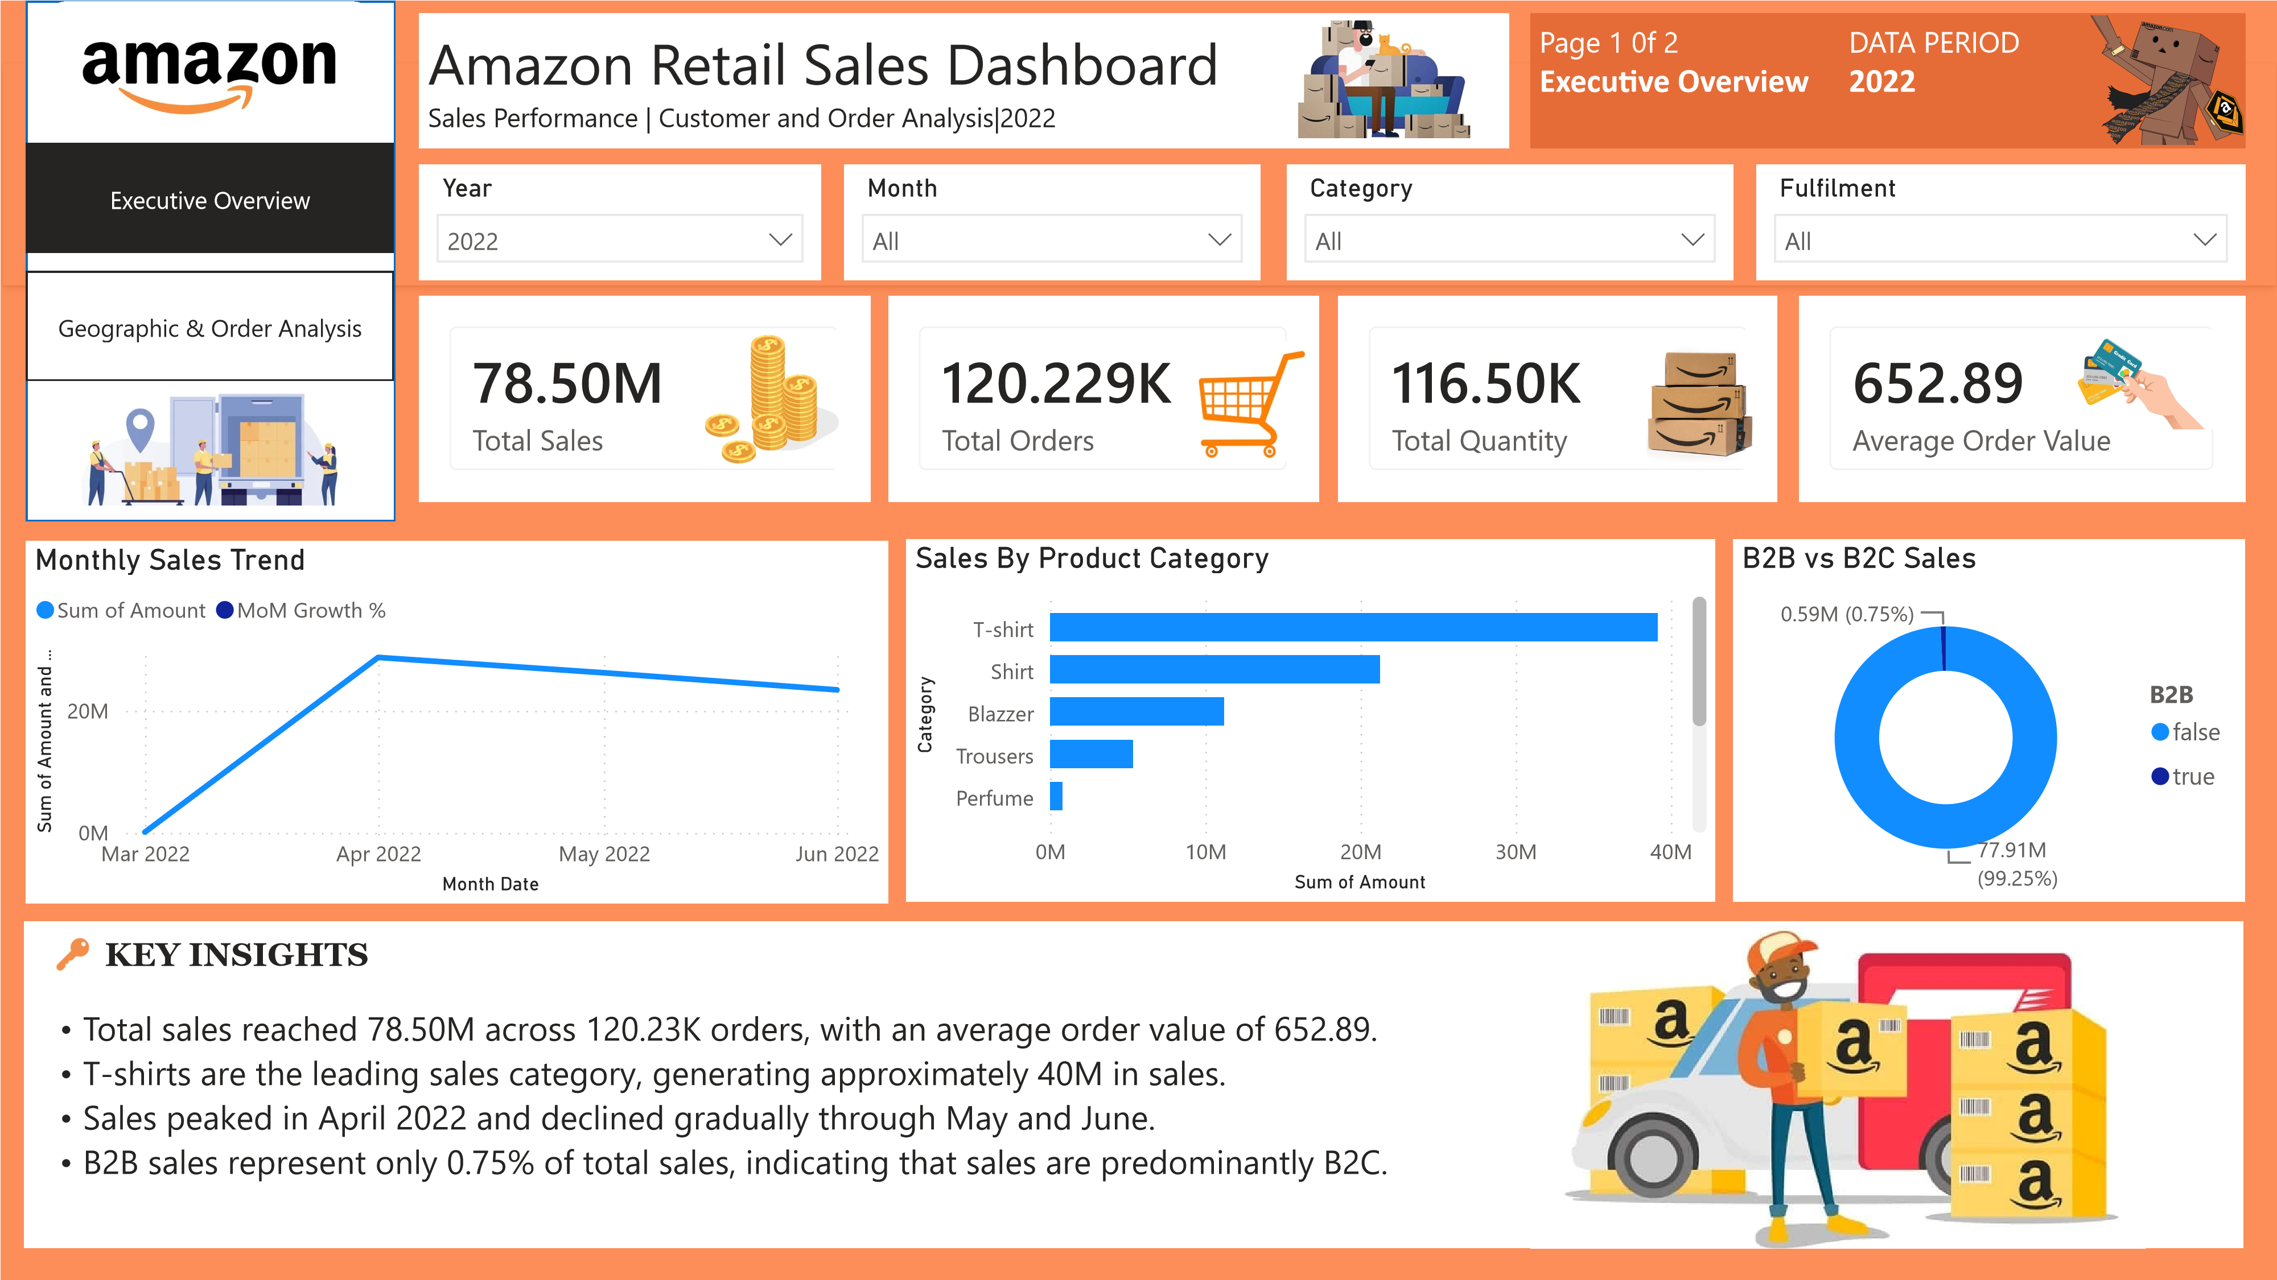
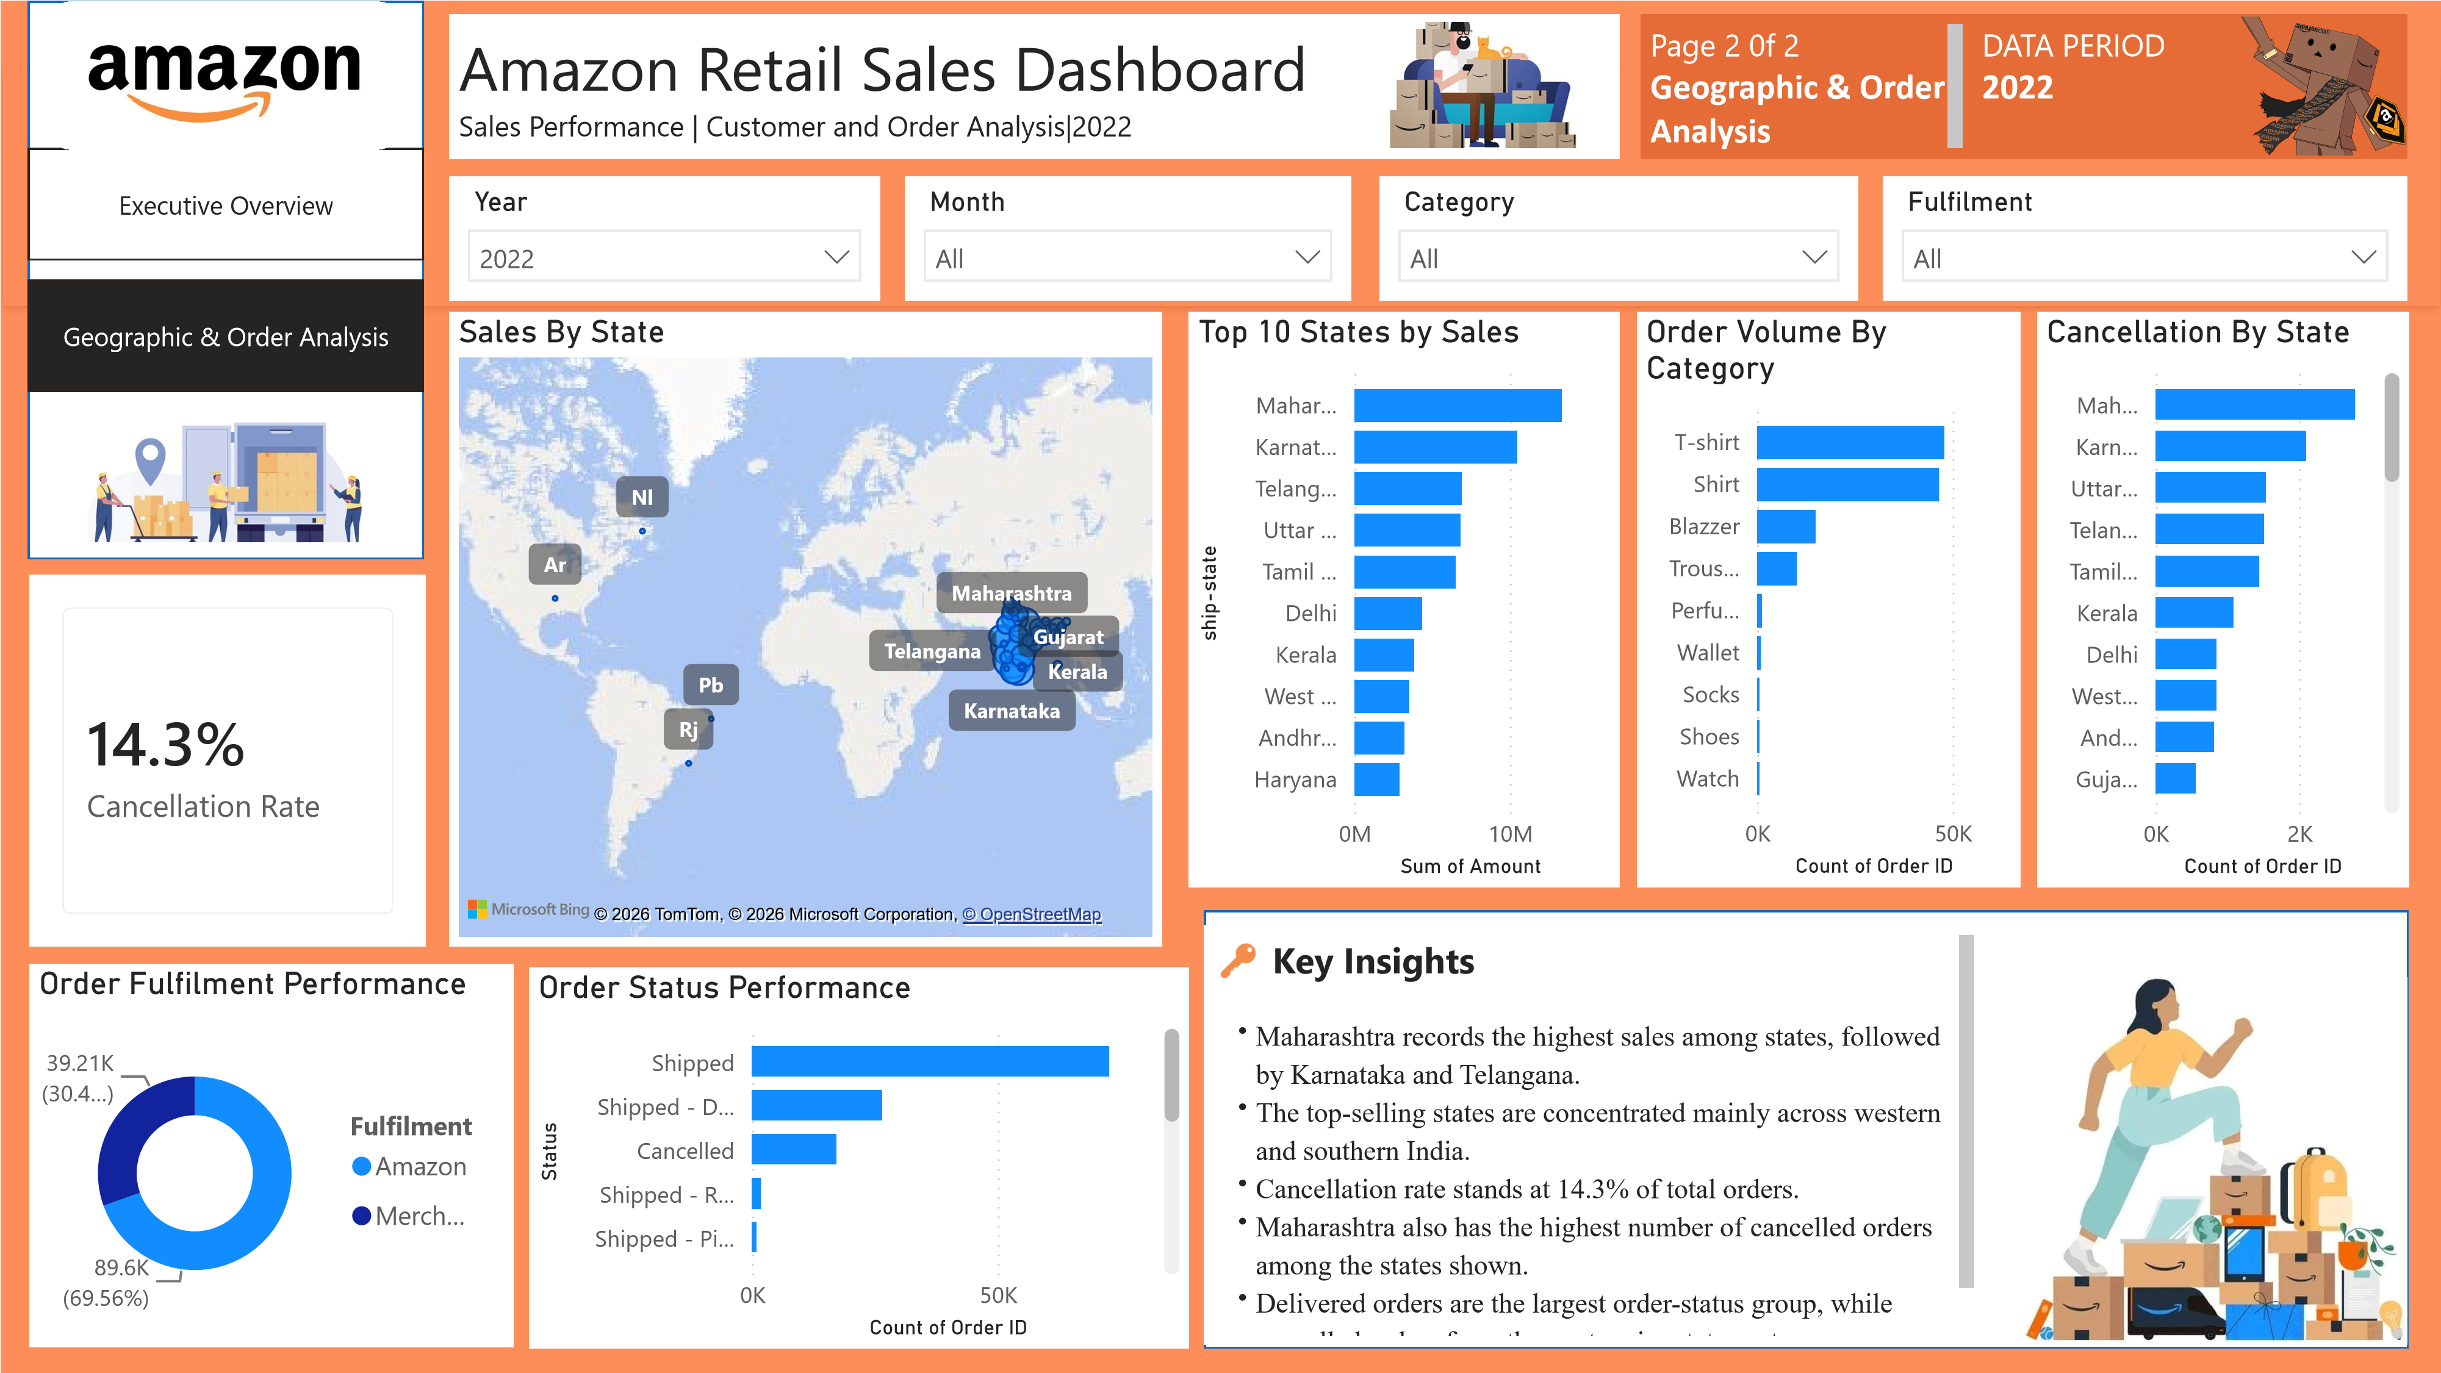

8. Key findings
- Total sales reached ₹78.50M across 120.23K unique orders, with 116.50K units sold and an average order value of ₹652.89.
- Sales peaked in April at ₹28.74M, before declining by 8.8% in May and a further 10.7% in June.
- T-shirts generated ₹39.15M (~50%) of total sales, followed by Shirts at ₹21.27M (~27%), together contributing approximately 77% of total sales.
- Maharashtra generated the highest sales at ₹13.32M, followed by Karnataka at ₹10.47M. The top five states contributed approximately 56% of total sales.
- Amazon fulfilment accounted for 69.6% of fulfilment records (89,595), compared with 30.4% (39,213) for Merchant fulfilment.
- The overall cancellation rate was 14.3%, with Maharashtra recording the highest number of cancelled orders.
- B2C sales accounted for 99.25% of total sales (₹77.91M), while B2B contributed 0.75% (₹0.59M).
9.Business takeaways
- ₹653 AOV provides a baseline for monitoring customer basket size.
- Sales declined after April; further data is needed to determine whether this is seasonal or a sustained slowdown.
- T-shirts and Shirts drive ~77% of sales, making inventory availability especially important.
- Sales are concentrated in western and southern states, highlighting opportunities for regional marketing and delivery optimisation.
- Amazon handles ~70% of fulfilment; comparing fulfilment performance can identify service improvement areas.
- The 14.3% cancellation rate warrants analysis by state, fulfilment method and category.
- B2B contributes only 0.75% of sales, indicating a predominantly B2C customer base.
10.Tools: Microsoft Excel | PostgreSQL | Power BI
11.Skills: Data Cleaning | Excel PivotTables | SQL | PostgreSQL | Data Aggregation | KPI Analysis | Sales Trend Analysis | Regional & Category Analysis | Power BI | Data Visualisation | Dashboard Development | Business Insights
12.Github Link : View Project

